AI Committee Task
Chat MD
Technical Documentation


Date: 25/1/2025
Version: 1.1
Author:
Aly El-Badry

Contents
Overview 3
Core Objectives 3
System Architecture 3
Key Technical Capabilities 3
Scope 4
In Scope (Deliverables) 4
Out of Scope (Exclusions) 4
System Architecture 5
Data Flow Diagram 5
Core Components 6
Configuration & Secrets 7
Security Warning 7
Required Variables 7
API Reference 8
Format Session Description 8
Example Request 8
Example Response (200 OK) 8
Format Task Description 8
Example Request 9
Example Response (200 OK) 9
Error Handling 9
Github Repository 9

Overview
Chat MD is a Django-based backend service designed to automate and standardize the documentation workflow for the Star Union community. It functions as an intelligent middleware layer that transforms raw, unstructured user input into professionally formatted Markdown suitable for frontend rendering.
The system addresses the challenge of inconsistent communication by leveraging Generative AI to enforce strict formatting rules, tone consistency, and structural integrity across community posts.

Core Objectives
The primary goal of Chat MD is to decouple content creation from content formatting. It ensures that regardless of the input language (English, Arabic) or the input quality, the final output adheres to specific community standards.

System Architecture
The project is built on Django and exposes a RESTful API architecture with two distinct endpoints, each governed by a specialized prompt engineering logic:
- Session Description Endpoint:
  - Purpose: Processes weekly session recaps and educational content.
  - Logic: Focuses on narrative flow, technical summarization, and "timeless" content generation (stripping transient logistics like dates/rooms). It enforces an energetic, community-centric tone.
- Task Description Endpoint:
  - Purpose: Processes internal task assignments for members.
  - Logic: Focuses on actionability and technical precision. It converts prose into structured checklists (- [ ]), highlights constraints (e.g., dimensions, colors), and enforces imperative action verbs.

Key Technical Capabilities
- Multilingual Normalization: Automatically detects and translates mixed-language inputs (Arabic/Franco) into professional technical English.
- Smart Parsing: Identifies and formats embedded media (image URLs) and transforms raw hyperlinks into descriptive Markdown anchors.
- Tone Enforcement: Injects brand-specific styling and signatures (e.g., "Reach for the stars! 🌟") programmatically.
- JSON-to-Markdown Pipeline: Delivers raw Markdown strings encapsulated in JSON payloads, ensuring seamless integration with frontend Markdown renderers.

Scope
This section outlines the specific capabilities of the Chat MD backend service, defining what is included in the current release and what is excluded.

In Scope (Deliverables)
The Chat MD system is built to automate the following core functions:
- Automated Content Formatting:
  - Session Descriptions: Instantly converts rough notes into engaging, structured summaries for the website.
  - Task Lists: Transforms vague instructions into clear, actionable checklists for team members.
- Intelligent Standardization:
  - Language Unification: Automatically translates all input (English, Arabic, or Franco) into professional English.
  - Brand Consistency: Ensures every output matches the "All Star Union" tone and includes the signature sign-off ("Reach for the stars! 🌟").
- Smart Media Handling:
  - Visuals: Detects image links and properly displays them as banners.
  - Resources: Converts messy URLs into clean, clickable links with descriptive titles.
- Privacy & Clean-Up:
  - Automatically removes temporary logistics (like dates and room numbers) from public session descriptions to keep content "evergreen."

Out of Scope (Exclusions)
The following items are not part of this backend service:
- Visual Rendering: The system provides the content (text/markdown), but the frontend website/app is responsible for displaying it (colors, fonts, layout).
- File Hosting: The system formats existing links; it does not store or host images/files itself.
- Fact checking: The AI formats the input provided; it does not verify the technical accuracy of specific details (e.g., code syntax).
- Direct Posting: The system prepares the content; it does not automatically post it to social media or project management tools.

System Architecture
Chat MD operates as a modular Django app integrated within the main backend monolith. It follows a Service-Oriented Architecture (SOA) pattern where the "Formatting Logic" is decoupled from the "View Logic."
The system functions as a robust Middleware Pipeline that:
- Ingests raw, unstructured text via RESTful endpoints.
- Validates input integrity using DRF Serializers.
- Injects context-aware prompt engineering (Session vs. Task personas).
- Generates structured Markdown via Google Gemini API.

Data Flow Diagram
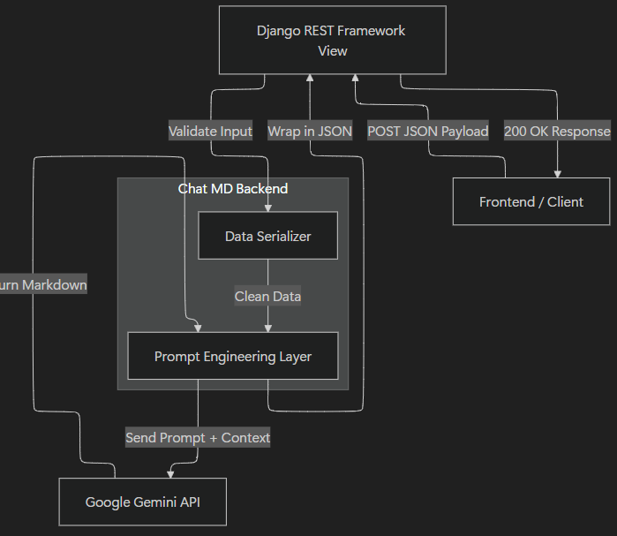

Core Components
1. The Interface Layer (DRF)
- Role: Handles HTTP requests, permission checks, and response formatting.
- Implementation: Two specific API View endpoints (Format Description, Format Task).
- Validation: Uses serializers.TextRequestSerializer to ensure text is present and non-empty before hitting the expensive AI layer.
2. The Service Layer (Prompt Engineering)
- Role: The "Brain" of the application. It holds the proprietary system instructions (The "Editor" and "Project Lead" personas).
- Logic:
  - Sanitizes input (trims whitespace).
  - Constructs the final prompt: System Instruction + User Input.
  - Manages API timeouts and error handling (e.g., if Gemini is down).
3. The Inference Layer (External)
- Role: Text generation and reasoning.
- Provider: Google Gemini (Generative AI).
- Configuration: Model: Gemini flash and flash-lite model

Configuration & Secrets
The Chat MD service relies on environment variables to manage sensitive credentials (API keys) and configuration settings securely. These variables are loaded at runtime, keeping secrets out of the codebase.

Security Warning
CRITICAL: Never commit your .env file to GitHub or version control.
- Ensure .env is listed in your .gitignore file.
- If you accidentally commit this file, you must revoke and regenerate your Google API Key immediately.

Required Variables
Variable Name | Required? | Description | Example Format
GOOGLE_API_KEY | Yes | The API key for Google Gemini (Generative AI). | AIzaSy...
DJANGO_SECRET_KEY | Yes | Django's cryptographic signing key. | django-insecure-...
DEBUG | No | Toggle debug mode. Set to False in production. | True or False
ALLOWED_HOSTS | No | List of valid hostnames (for production). | localhost,127.0.0.1

API Reference
Content-Type: application/json

Format Session Description
Endpoint: POST /format/description/
Description: Generates a public-facing, high-energy session summary.
- Logic: Automatically detects images, strips specific dates/locations, and enforces the "All Star" tone.
Requested Parameter.
Parameter | Type | Required | Description
text | String | Yes | The raw notes or rough paragraph to be formatted.

Example Request
{
"text": "We had a workshop about Flutter yesterday. We covered Widgets and State Management. Here is the banner: https://example.com/flutter.png"
}

Example Response (200 OK)
{
"markdown": "## Flutter Workshop: Building Interactive UIs\n\n![Session Banner](https://example.com/flutter.png)\n\nIn this session, we dove deep into the power of **Flutter**..."
}

Format Task Description
Endpoint: POST /format/task/
Description: Generates an internal, actionable task list for team members.
- Logic: Converts instructions into checkboxes (- [ ]) and highlights constraints.

Request Parameters
Parameter | Type | Required | Description
text | string | Yes | The vague instruction or requirement.

Example Request
{
"text": "Please fix the login button. It needs to be brand blue #0055FF and 50px height."
}

Example Response (200 OK)
{
"markdown": "## Task: Refactor Login Component\n\n### 📋 Requirements\n- [ ] Update button background to **#0055FF**.\n- [ ] Set button height to fixed **50px**."
}

Error Handling
Status Code | JSON Response | Description
400 | {"text": ["This field is required."]} | Missing text field in request.
500 | {"error": "Error message from AI..."} | Internal server error or AI service failure.

Github Repository
- Link of github repository: Link

